CY-321 Secure Software Development
Project Deliverable 1


Project Title: CampusTrade

Muaaz Bin Salman – 2023338
Syed Daud – 2023677

Submitted to: Dr. Zubair

- Executive Summary & Problem Statement
Students need a secure place to trade items, but social media groups lead to fraud and data exposure. CampusTrade is a simplified, secure web marketplace where accounts are tied exclusively to institutional identities. Security is integrated from the start, focusing on protecting against the most critical web vulnerabilities.

- Core Security Requirements
- Authentication: Passwords must be hashed using bcrypt before database storage.
- Verification: Registration only accepts emails matching the .edu domain pattern.
- Brute-Force Protection: Accounts lock temporarily after 5 failed login attempts.
- Authorization: Object-level authorization ensures users can only edit or delete listings they own.
- Injection Prevention: All database queries must use parameterized statements via an ORM to prevent SQL Injection.
- XSS Prevention: All user-submitted text (like product descriptions) must be sanitized before rendering.

3. Critical Risk Management
Risk | Score (1-25) | Actionable Mitigation
SQL Injection | 25 (Critical) | Use ORM parameterized queries.
Broken Authentication | 20 (Critical) | Enforce bcrypt hashing and account lockouts.
Cross-Site Scripting (XSS) | 16 (Critical) | Sanitize listing descriptions with DOMPurify; rely on React JSX auto-escaping.
Broken Access Control | 15 (Critical) | Verify owner_id against the authenticated user before any database write.
Insecure File Uploads | 12 (High) | Validate MIME types and enforce a 20MB limit on image uploads.

4. STRIDE Threat Model
Threat Category | Scenario | Implemented Control
Spoofing | Attackers use fake emails to register. | Regex validation blocks non-university emails.
Tampering | User modifies an HTTP request to edit someone else's item. | Server verifies the item belonging to the requester before updating.
Repudiation | User denies creating a fraudulent listing. | A basic, append-only database table logs listing creation event.
Information Disclosure | API accidentally sends password hashes to the frontend. | Explicit whitelisting on API responses ensures hashes remain hidden.
Denial of Service | Attacker spams the login route. | Basic rate-limiting middleware throttles repeated requests.
Elevation of Privilege | User manipulates a JWT token to gain extra rights. | Server rejects tokens with invalid cryptographic signatures.

Simplified 3-Tier Architecture Diagram
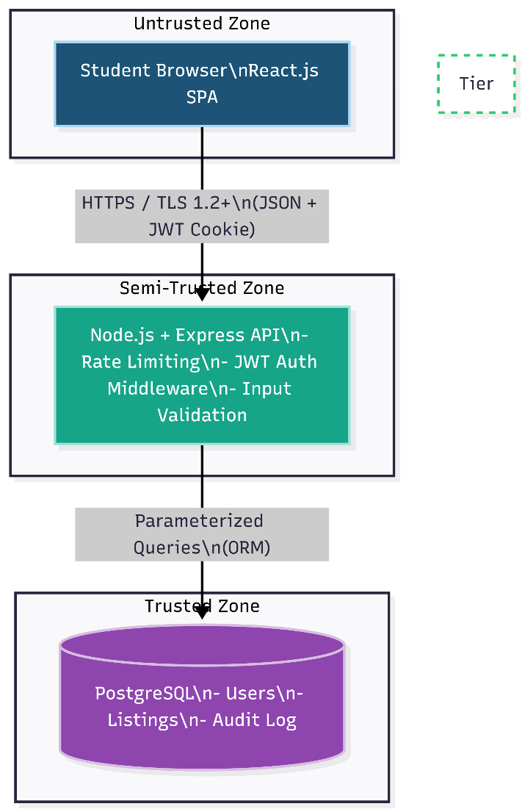
Level 1 Data Flow Diagram (DFD)
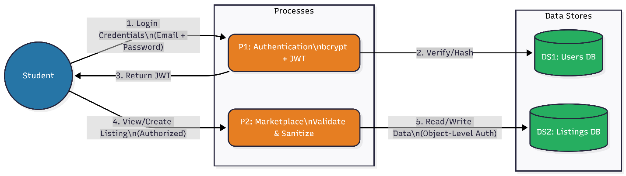

Streamlined Authentication Flow
